**2025 NTHU CS5553 Data Science for Digital Health Homework 1**

**X1136010 黃偉祥**

#HW1-1 Predicting Mortality of Pulmonary Embolism Patients in the ICU (50%)

1. Flowchart1

Adults (age ≥ 21) in ICU

with pulmonary embolism

(N = 1810) (30%)

Alive in hospital

(N = 1519) (10%)

Die in hospital

(N = 291) (10%)

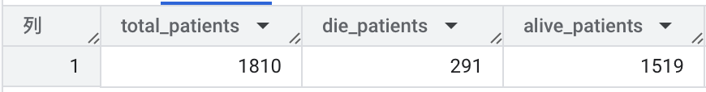

1. Describe your data extraction steps and your findings.

(Remember to show your code either in the report or in your attachment. Points will be deducted if there is no code or explanation.)

1. Get all adults (age>=21) in ICU with pulmonary embolism, using tables mimiciv_hosp.d_icd_diagnoses, mimiciv_hosp.diagnoses_icd, mimiciv_hosp.patients, mimiciv_icu.icustays.
   1. diagnoses_icd to get the patients (subject_id) with specific icd_code
   2. icu for get patients(subject_id,hadm_id) that stay in icu
   3. patients table for age constraints
2. Use mimiciv_hosp.admissions table to get the patient died or not in hospital using hospital_expire_flag (1->die, 0->alive).
   1. Use MAX() to get if the patient is 1 or 0 in the end, if all record is 0 then alive, if any 1 record is 1 then die.
   2. Count the record with 0 as alive patient and 1 as die patient

#HW1-2 Predicting Successful Discontinuation of Continuous Renal Replacement Therapy (50%)

1. Flowchart2

Adults (age ≥ 21) in ICU requiring hemodialysis

(N = 1935) (20%)

In hospital death within 84 hours after latest hemodialysis order

Underlying “ESRD”

Included patients

(N =555) (20%)

Discontinuation group

(N = 450) (5%)

Re-initiation group

(N = 105) (5%)

Exist a successful

discontinuation record



1. Describe your data extraction steps and your findings.

(Remember to show your code either in the report or in your attachment. Points will be deducted if there is no code or explanation.)

1. First, I use same method as HW1-1 to get all patients age >= 21 and order_type = ‘Hemodialysis’ and stay in icu
2. Create a table with patients that icd_code is either 5856x or N186x
3. Find patients died in Hospital within 84 hours after latest Hemodialysis order with 2 table, 1 table to get latest order and 1 table checks died in hospital or not.
4. Then use 1. And LEFT JOIN 2. 3. to do exclusion and get included patients
5. Discontinuation Group
   1. Use LAG() to get previous order time and calculate each time gap
   2. Use last order time and discharge of hospital time (if last order to leave hospital is more than 84 hour)
6. Then use included patients – Discontinuation Group to get Re-initiation Group